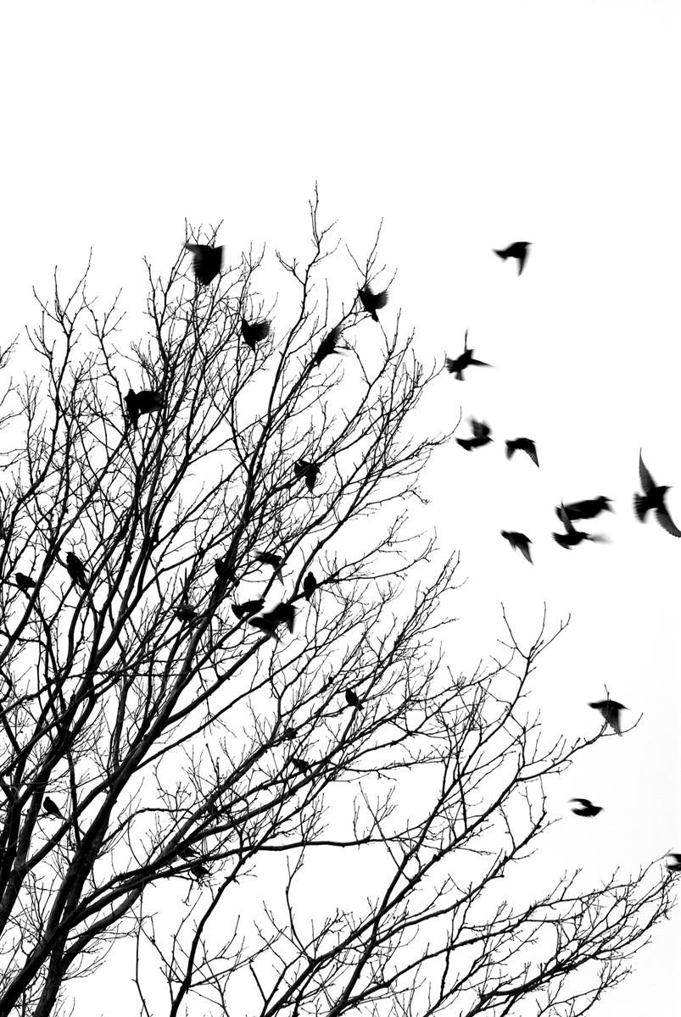
On July 28, 2015
the Hudson Essex Passaic Soil Conservation District
will relocate to 80 Orchard St, Bloomfield, NJ 07003

The offices will be closed to the public on this day.
We appreciate your patience and understanding during our transition. Mail & phones will be forwarded for a time.

After August 3, 2015, please use our new numbers:
Phone 862-333-4505
Fax 862-333-4507

Staff will then be reached at the following extensions:
Ext 310 Fran Aguirre, Office Manager (espanol)
Ext 311 Janet Rekesius, Administrative Services
Ext 312 Glen Van Olden, District Manager
Ext 313 Matt D’Alessandro, Senior Erosion Control Inspector
Ext 315 Dave Malka, Erosion Control Inspector

